|  |  |  |  |
| --- | --- | --- | --- |
| **Grades 2- 6 Focus on the Pope and the 2013 Conclave**  What Happens at a Conclave? | | | |
| Teacher’s Note:  Children this age often know some information about the pope and his role. They also tend to be very rule-oriented, so they will need to know that even though a pope is usually chosen for life, it’s not “against the rules” for the pope to resign. He can do so if he feels he cannot carry out all of his responsibilities. Then, a new pope is chosen by all of the cardinals from around the world, who will meet in Rome for a conclave. Encourage children this age to pray for the cardinals as the elect the new pope, that the Holy Spirit will guide them as they choose a strong and faithful leader for the Church. | | | |
| CGEs  A discerning believer formed in a Catholic faith community  An Effective Communicator  A Collaborative Contributor | | | |
| Curriculum Expectation  New Elementary Religious Education Policy  This lesson is strongly connected to the *Big Idea* that the Church is a hierarchical structure and a unity of persons who share one common mission to building up the reign of god on earth.  Specific Expectations:  Grade 4  Strand: Living in Solidarity, LS1.2, LS1.3  Grade 6  Strand: Believing: BL 3.2  Strand: Celebrating: focus on Holy Orders, CL 1.2  Strand: Living in Communion: LC 1.2  Language  Reading  1.3, 1.4, 2.1,  Oral Language  2.1, 2.2, 2.3, 2.4. 2.5,  Media Literacy  1.1, 1.3 | | Learning Goals:  I will use a variety of reading and viewing strategies to improve my comprehension of non-fiction text.  I will present a News Interview which will explain how the new pope is elected during a conclave in an entertaining way.  I will use the new vocabulary properly.  I will work collaboratively with a partner. | |
| Prayer/Scripture Reflection  Loving Father, we ask you to bless Pope Benedict XVI. Let him find a sense of peace in his old age and allow him the fortitude  and temperance to retire to a life out of the public eye.  Send forth the Holy Spirit to guide the decisions of the Cardinals in the upcoming Conclave.  Grant that their collective wisdom choose the best man -  One who like a good shepherd will lead and guide the global Church  with compassion, justice and hope. Amen. | | | |
| **Instructional Components** | | | |
| **Readiness**   * Awareness of the role of the pope within the world church * Previous use of KWL charts to activate schema * Reading Strategies: monitor comprehension, asking questions, identify and analyze important ideas * Oral Language Strategies: Building on each other’s ideas * Familiarity with role play and creative design | **Vocabulary/Terminology**  Pope: papacy, papal  resign  Conclave  Cardinal; Cardinal Dean  The Vatican  Sistine Chapel  Room of Tears  Casa di Santa Marta  Zucchetto  Swiss Guard  inconclusive  Cardinal Collins  Cardinal Turcotte  Cardinal Ouellet | | **Materials/Resources**  KWL chart, sticky notes  Chart “What a Pope Does” for Primary students  Ppt: Electing a New Pope  BLM1: enough copies for pairs of Junior Students  Ppt: **How a Pope is Elected – The Vatican Insider**: <http://vaticaninsider.lastampa.it/en/the-vatican/come-si-elegge-il-papa/>  BLM2: How to Elect a Pope  Appendix 3: Roman Catholic Cardinals of Canada  A Guide to Effective Instruction, Grades 4-6: Volume 4, Oral Language, pp. 118-122  Examples of News Interviews to watch and analyze. |
| **Day 1**  **Minds On:**  **Share an image of Pope Benedict (from the school lobby, cut out from recent newspapers/magazines, from a website noted in this lesson packages Additional Resources file).**  **Read the following:**  **A**fter almost eight years of leading the Catholic Church, 85-year-old Pope Benedict XVI announced on Feb. 11 his intention to resign the papacy on Feb. 28, 2013. Pope Benedict is **only** the fifth pope in the history of the papacy to resign and the first in nearly 600 years.  *Grade 2 & 3 only*: Pope Benedict felt too he was too sick and weak to do his job well. Let’s make a list of the things a pope is expected to do.  Possible bullets:   * *Leader of the world-wide Catholic Church* * *Proclaims the Good News to the world* * *Says mass and celebrates the sacraments* * *Prays* * *Holds both private and general audiences where he greets and blesses people* * *Prepares and gives many speeches* * *Attends many meetings both in and outside of the Vatican* * *Writes books and other important papers on Church matters* * *Tweets his thoughts* * *Travels all around the world, meeting and teaching both Catholics and non-Catholics about Jesus’ mission* * *We can see from our list that the Pope is very busy. Pope Benedict felt at his age, he didn’t have the strength and health to do his work well anymore.*   Share ppt: Electing a New Pope  *Grades 4 and 5 only:*  With a partner, read through his address. Circle any unfamiliar words and use context clues and the dictionary to find their meaning. Then answer this question: **Why did Pope Benedict step down?** Highlight the information from this piece of text that answers this question; both of you must agree with this evidence from the text before anything is marked.  Select several partners to share identify new vocabulary and share thinking to the question.  Continue and state: The Pope has called for a Conclave of the Catholic Church’s Cardinals to elect the next pope. We are going to learn about Conclaves today. But first we will activate our prior knowledge to see right now what we know and what we wonder.  Create a KWL Chart to assess the prior knowledge related to Conclaves and the process of choosing a Pope. | | | |
| **Day 2**  **Activation:**  Review the KWL chart from yesterday’s lesson.  The Reading Strategies being activated are monitoring comprehension and identifying and analyzing important details with non-fiction text.  View and interact with **ppt How a Pope is Elected – The Vatican Insider**: <http://vaticaninsider.lastampa.it/en/the-vatican/come-si-elegge-il-papa/>  NOTE: With access to technology, the viewing of the ppt can be done whole class on a Smart board or independently if the ppt is loaded onto the school laptops.  If viewing in pairs, encourage student to ask questioning and comment on what they see and read to each other, as they proceed through the ppt at their own pace. Following this initial viewing, students will independently complete BLM2.  Take up the answers from BLM2. State: There are three Cardinals from Canada who will be participating in the Conclave. One is Cardinal Thomas Collins from the Archdiocese of Toronto. He became a Cardinal last year in 2012. Another is Cardinal Jean-Claude Turcotte of the Archdiocese of Montreal and the third is Cardinal Marc Ouellet who was the Archbishop of Quebec. Currently, he is working at the Vatican heading up the Congregation of Bishops which suggests to the Pope the names of priests from around the world who should be made Bishops. Cardinal Ouellet is also the president of the Commission for Latin America where over half of all Catholics live. Many people think that he is one of the front runners in the vote for the next pope.Soon the world will be following the Conclave, trying to guess who the next pope will be. In partners, you will create and perform a role play involving a news reporter from one of our national news networks sent to interview one of the Cardinals from Canada who is about to enter the Conclave. You will need to take the information that you learned about Pope Benedict and the process of the Conclave and share it in an entertaining way that .Let’s brainstorm and create success criteria for what we think an excellent TV news interview would include.Introduction, setting, tone Refer to pp.118- 122, Teaching the Interview, Volume 4 of the Guide to Effective Instruction for other teaching ideas and examples of observation checklists that can be used. QuestionsFollow-up questionsComments that elicit responseEvidence that the interviewer is listeningClosingThank youIt is equally important to consolidate the new learning about the Conclave process as it relates to Religious Education.Develop initial look-fors, assign partners and set presentation date(s).Day 3 + 4Watch a news interview together and evaluate it on the criteria developed. Is there any modification to the success criteria that needs to occur?Review Collaboration skills and give time for partners to write, revise their interview script, and practice it. As Interview role-plays become more polished, invite groups to present to each other for feedback based on the News interview success criteria. | | | |
| **Consolidation**  Present News Interviews. Use Appendix  Use Success Criteria for effective descriptive feedback and both peer and self-assessment and teacher. Suggested Extensions:Create short videos/movies of the News Interview with a Cardinal role plays.Have the students present to other grades who are also learning about the Conclave.Create costumes that reflect the ceremonial dress of a Cardinal. | | | |

BLM1 Names: __________________________

Pope Benedict’s Resignation Address

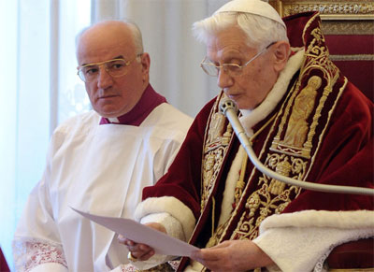

Dear Brothers,

I have convoked you to this Consistory, not only for the three canonizations, but also to communicate to you a decision of great importance for the life of the Church.

After having repeatedly examined my conscience before God, I have come to the certainty that my strengths, due to an advanced age, are no longer suited to an adequate exercise of the Petrine ministry. I am well aware that this ministry, due to its essential spiritual nature, must be carried out not only with words and deeds, but no less with prayer and suffering. However, in today’s world, subject to so many rapid changes and shaken by questions of deep relevance for the life of faith, in order to govern the bark of Saint Peter and proclaim the Gospel, both strength of mind and body are necessary, strength which in the last few months, has deteriorated in me to the extent that I have had to recognize my incapacity to adequately fulfill the ministry entrusted to me.

For this reason, and well aware of the seriousness of this act, with full freedom I declare that I renounce the ministry of Bishop of Rome, Successor of Saint Peter, entrusted to me by the Cardinals on 19 April 2005, in such a way, that as from 28 February 2013, at 20:00 hours, the See of Rome, the See of Saint Peter, will be vacant and a Conclave to elect the new Supreme Pontiff will have to be convoked by those whose competence it is.

Dear Brothers, I thank you most sincerely for all the love and work with which you have supported me in my ministry and I ask pardon for all my defects. And now, let us entrust the Holy Church to the care of Our Supreme Pastor, Our Lord Jesus Christ, and implore his holy Mother Mary, so that she may assist the Cardinal Fathers with her maternal solicitude, in electing a new Supreme Pontiff.

With regard to myself, I wish to also devotedly serve the Holy Church of God in the future through a life dedicated to prayer.

From the Vatican, 10 February 2013

BLM2

How to Elect a Pope Name ________________________________

View and read the captions of the ppt once, then answer as many questions as you can. Review the ppt to find any answers you could not recall. Circle the numbers of these answers to remind you that you are developing important comprehension skills when you re-read and review both print and visual text to locate both specific and important details.

1. *Match the vocabulary word to its meaning:*

Swiss Guard location of the Conclave with the Vatican

Sistine Chapel oath taken by the cardinals attending the Conclave

Zucchetto hotel-like residence where cardinals stay during Conclave

Cardinal the special Vatican police force who maintain law and order

protect the Pope

Conclave in Latin, *cum clave*, meaning “locked in”

Room of Tears without a 2/3 majority vote; no clear choice of a winner

Cardinal Dean tight, round, beanie-like head covering worn by bishops, cardinals and the pope; each group has its significant colour

Casa di Santa Marta quiet dressing room and place for prayer used by the pope

Inconclusive special title and office given to selected Bishops whose main purpose is to select the next pope

Secundum Deum most senior Cardinal who presides over the College of Cardinals

1. *Answer the following questions in complete sentences in your Religion notebooks.*
2. Where does the Conclave?
3. Name the three (3) orders/groups within the College of Cardinals.
4. What is the purpose of the Conclave?
5. Who participates in the voting?
6. What criteria must be met in order to become pope of the Catholic Church?
7. What type of process is used to elect the pope?
8. How many votes must the new pope receive?
9. After each round of voting, the ballots are tied and burned. If black smoke is seen by the crowds gathered in St. Peter’s Square, what does this mean? What if the smoke is white?
10. Why do you think the man elected takes a new name as pope?
11. Why do you think that the cardinals wear red?
12. Copy the Latin, ritual phrase that is announced by the Cardinal Dean and what you think it means.

BLM2 Answers

1. Where does the Conclave?

* Sistine Chapel, Vatican

1. Name the three (3) orders/groups within the College of Cardinals.

* Bishops, priests, deacons

1. What is the purpose of the Conclave?

* to elect the next pope

1. Who participates in the voting?

* All Cardinals under the age of 80 whose health allows them to travel

1. What criteria must be met in order to become pope of the Catholic Church?

* Baptized, unmarried, Catholic male over the age of 18 (all 4 needed)

1. What type of process is used to elect the pope?

* Secret ballot

1. How many votes must the new pope receive?

* 2/3 of the # of voting Cardinals

1. After each round of voting, the ballots are tied and burned. If black smoke is seen by the crowds gathered in St. Peter’s Square, what does this mean? What if the smoke is white?

* Black smoke: no consensus; another round of voting must take place
* White smoke: the vote has a 2/3 majority and a new pope has been picked

1. Why do you think the man elected takes a new name as pope?

* No Pope is obligated to change his name. This is a pious and not a Sacred tradition. The practice arose in 533 C.E. when a pagan convert to Christianity became Pope and changed his name from Mercury (after the pagan Roman god) to John II. Most popes who served from the year 1003 C.E. have changed their names. Most admire the qualities and talents of the person’s name they take.

1. Why do you think that the cardinals wear red?

* Scarlet reminds the Cardinals that they must be willing to give of themselves for the Church, even to the point of shedding their blood.

1. Copy the Latin, ritual phrase that is announced by the Cardinal Dean and what you think it means.

* Annuntio vobis gaudium magnum. Habemus Papem: I announce to you a great joy:  
  We have a Pope!

Appendix 1Canada’s Roman Catholic Cardinals attendin the 2013 Conclave

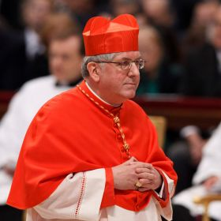 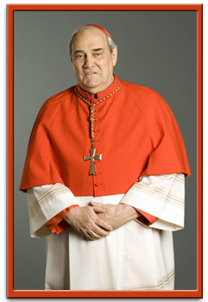

Cardinal Thomas Collins Cardinal Jean-Claude Turcotte

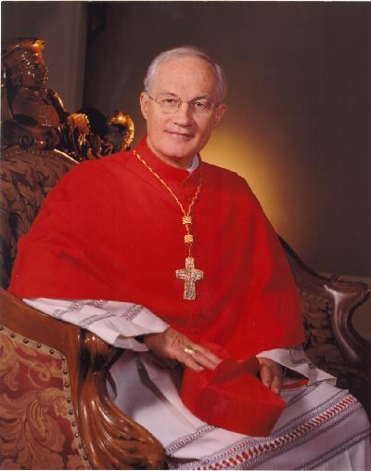

Cardinal Marc Ouellet

Appendix 2

Interview Observation Record Date:_________________

Interviewee:______________________________________________________

Interviewer:______________________________________________________

Purpose:

*A National News Network reporter will interview a Canadian Cardinal to report on the Conclave and the process that takes place to elect a new pope for the TV stations nightly audience.*

What I noticed and learned from the interviewer:

What I noticed and learned from the interviewee:

Other observations:

Insert your class’ Success Criteria Checklist here…remember you may look for:

1. Purpose
2. Openings
3. Types of questions
4. Voice, tone, and body language
5. Flow of ideas and information
6. Follow-up questions
7. Accuracy of the Conclave process and information about the role of the pope and cardinals
8. Proper use of new vocabulary related to the Conclave